AM000-Asia-Japan Mirror-Two Storks-Bronze-19th c

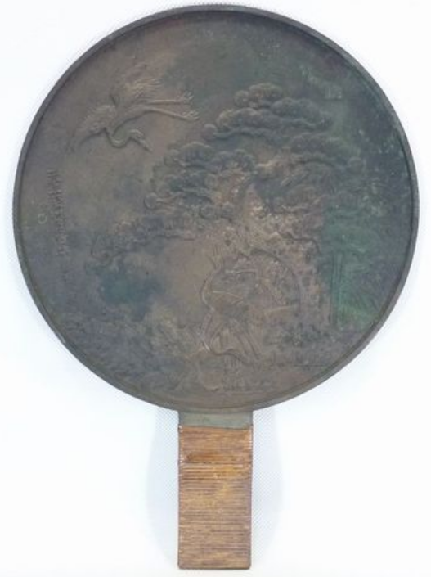

**Up for sale is an old Japanese bronze or copper mirror called Dokyo or Kagami, with symbols of felicity such as cranes, pine trees and bamboo trees casted on the back side. Please note that it's stained, scratched, rusted and tarnished (NOT possible for you to look yourself in the mirror).**

**Material : bronze or copper**

**Size (approx.) : H38cm/14.9" x 27cm/10.6" in diam.**

**Net weight (approx.) : 1.36kg/2.9lb**

**Gross weight (approx.) : 1.5kg/3.3lb**

**Age : mid - late 19th century or older**

**Condition : stained, scratched, rusted & tarnished**